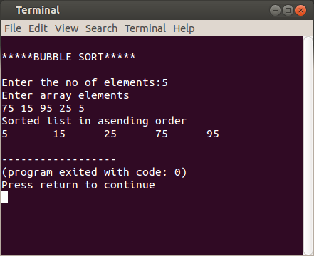8. BUBBLE SORT

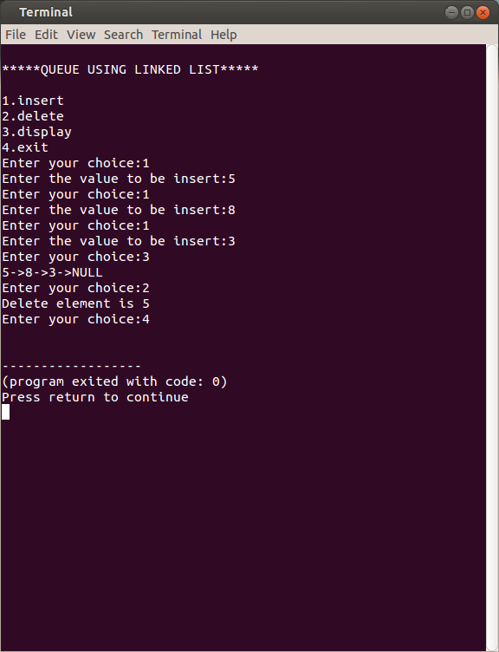

6. QUEUE USING LINKED LIST

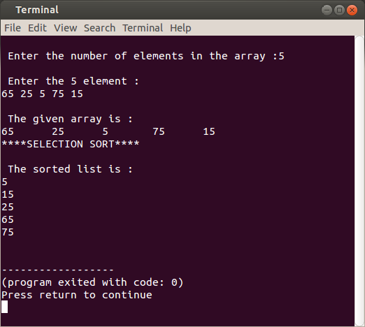

7.SELECTION SORT

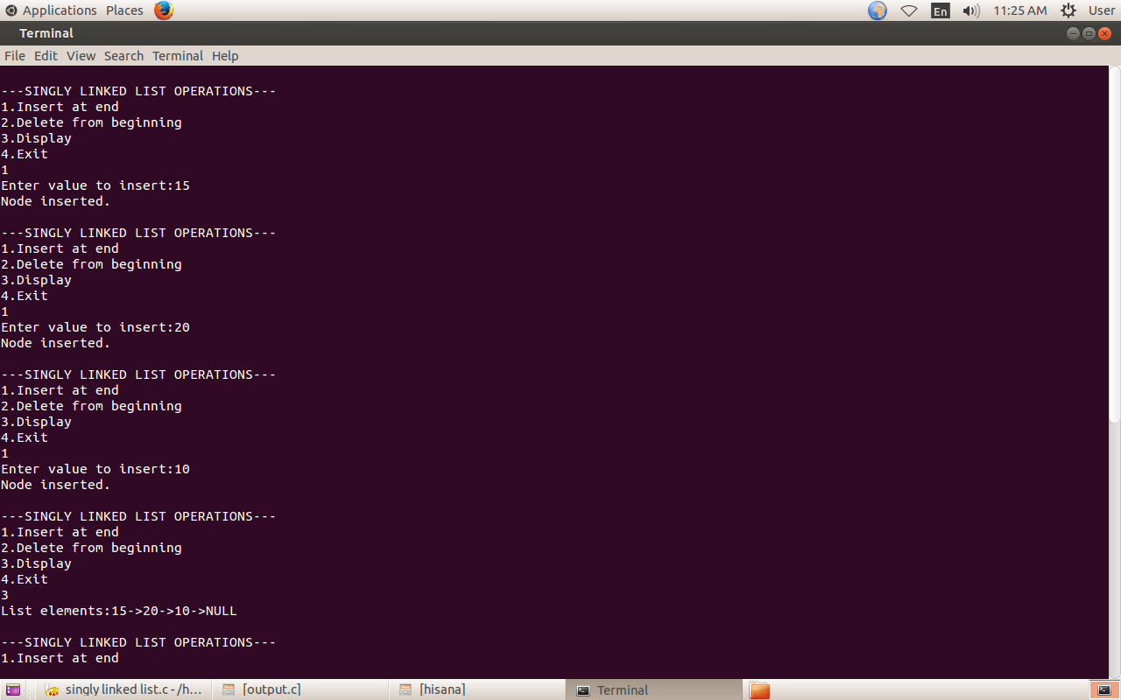

1.SINGLYLINKED LIST (1)

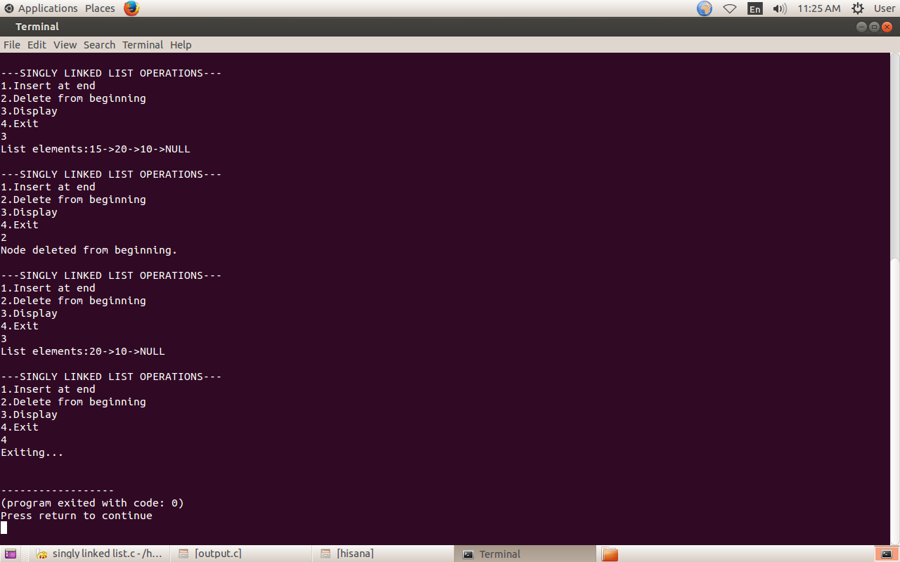1.SINGLY LINKED LIST (2)

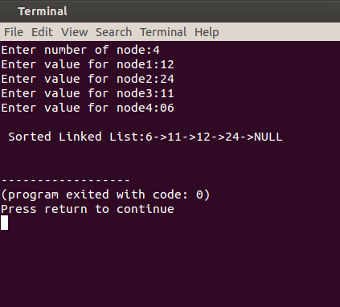2. SORT ELEMENTS SINGLY LINKED LIST

.

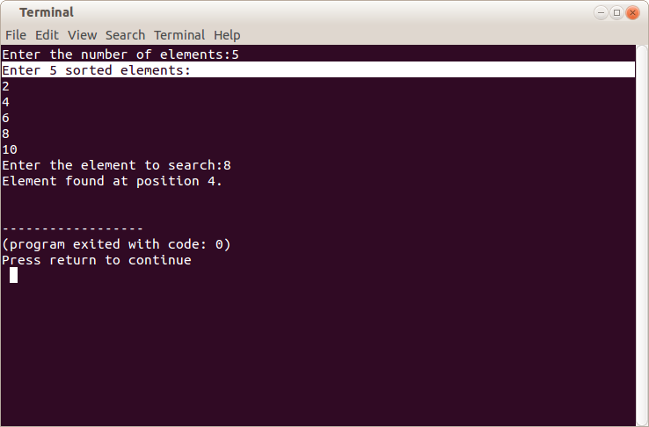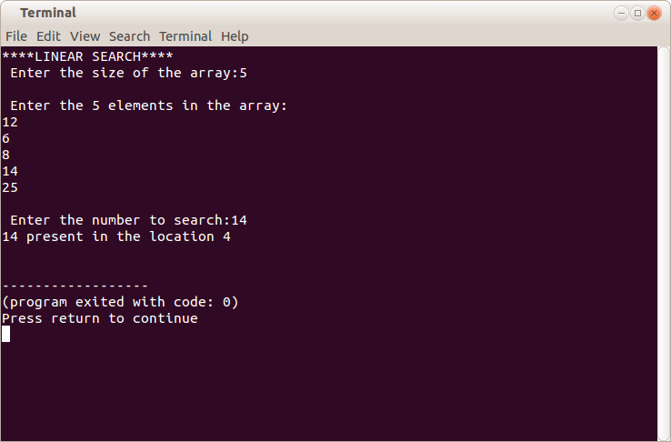10. BINARY SEARCH 9. LINEAR SEARCH

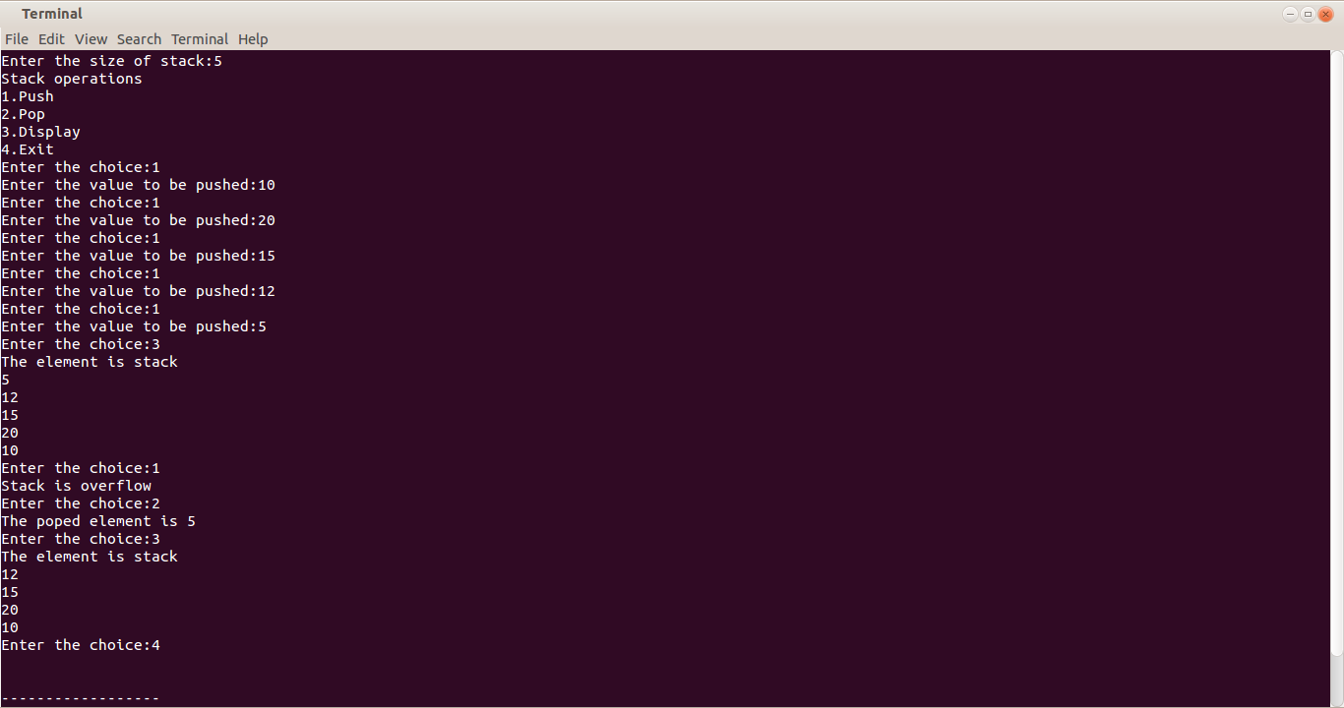

3. STACK USING

ARRAY

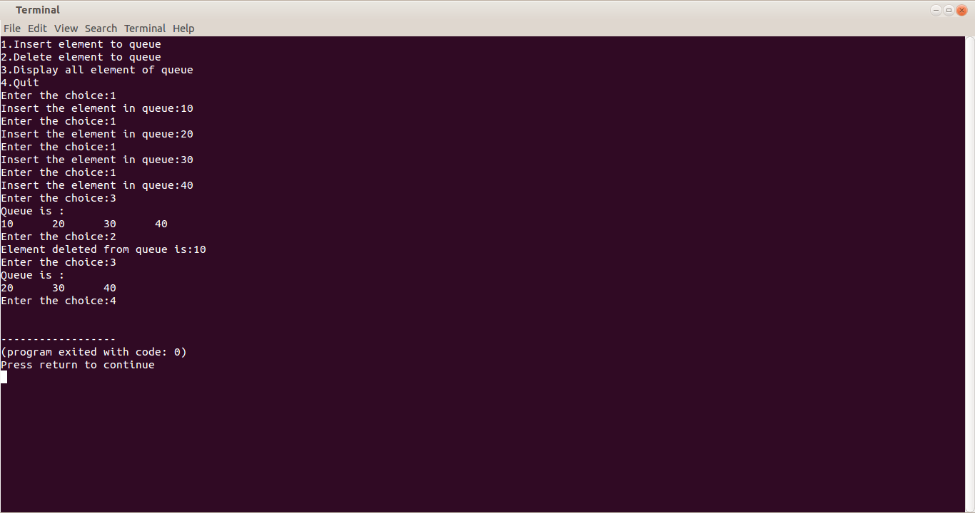

5. QUEUE USING

ARRAY